Mini project on Ansible

Setup an ansible controller on Ubuntu and write a playbooks with three plays. To install apache, to install Git and write a task using debug module

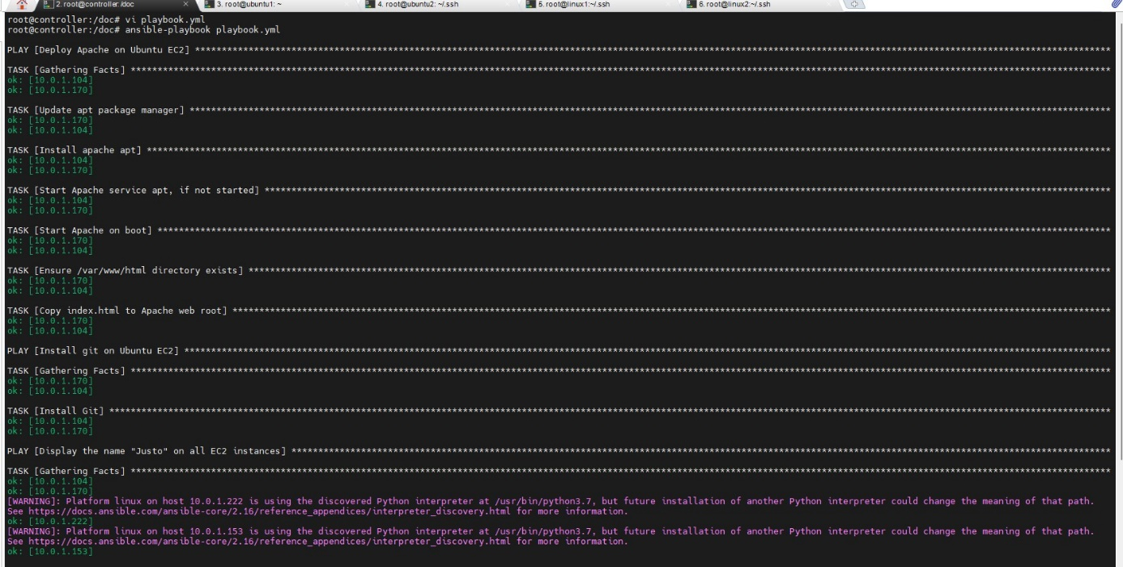

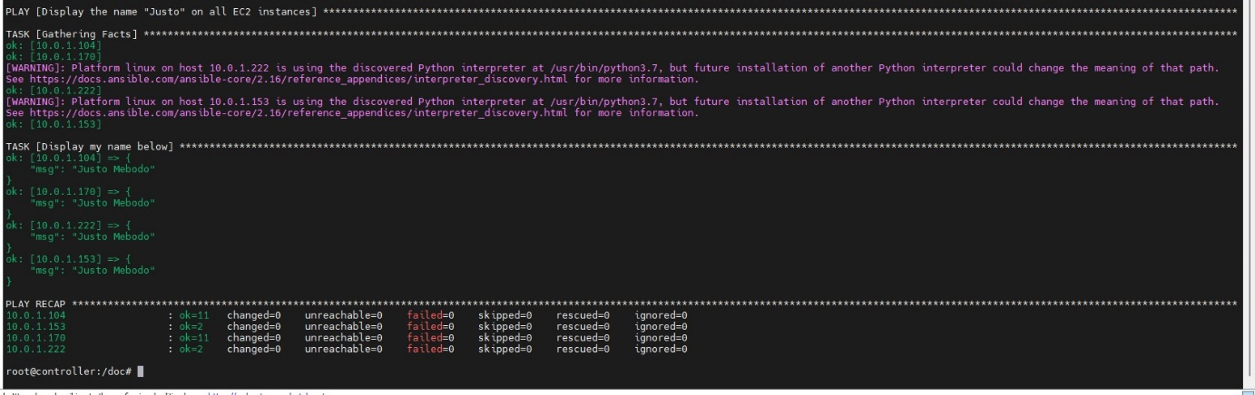

Message display for apache



Installation of Git

